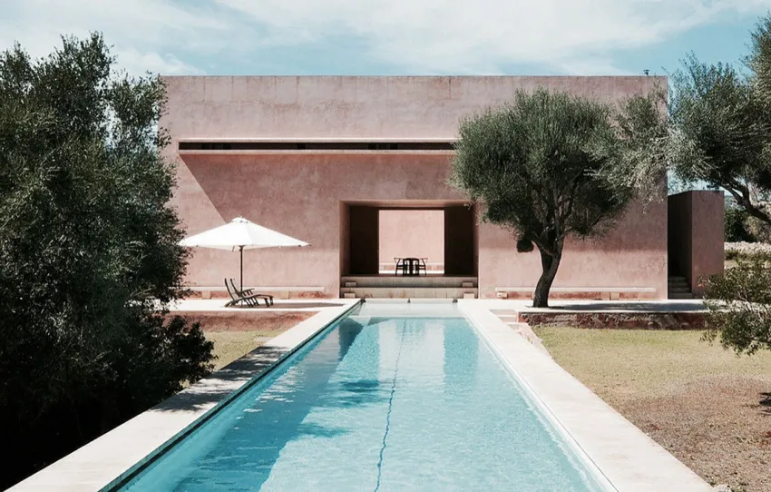Figure 1: Team, A. (2023). The Neuendorf House by John Pawson and Claudio Silvestrin in Mallorca. Retrieved from https://archeyes.com/neuendorf-house/
STUDENT ID: s8095544/MASSIMO LOVERSO massimo.loverso@live.vu.edu.au

Neuendorf House

How does the Neuendorf House reflect John Pawson's minimalist design principles?
Word count: 634 (without referencing)
The Neuendorf House, designed by architects John Pawson and Claudio Silvestrin , is located in Mallorca, Spain. This architectural masterpiece stands as proof to minimalist design principles. Pawson and Silvestrin have created a harmonious blend of precise attention to detail, execution, and a solid commitment to simplicity and clarity of space. Completed in 1991, the Neuendorf House continues to inspire many other world-renowned architects, as it provides a well-established principle of architectural mastery.
Pawson’s Attention to Detail and Craftsmanship
Pawson’s obsession with precision is profound in every corner of the Neuendorf House. Minimalism isn’t about emptiness, it’s about detailed craftsmanship. The house’s exterior, with its pink-tinted walls, appears simple. Yet, upon closer inspection, the refined cuts in the façade that cast complex shadows onto the courtyard. These shadows, ever-changing with the sun’s movement, transform the walls into dynamic backdrops. Pawson’s genius lies not only in what he includes but also in what he excludes. Every material, every joint, every seam is considered as beauty of control.
Inside the house, the utilization of light and shadow is quite evident. The slivers of window openings strategically positioned attract sunlight to forecast across the white walls. The quality of the materials and the coolness of stone underfoot provide warmth from sunlight filtering through which creates a connection with the environment. Pawson’s thinking aligns with this physical approach, carefully selecting essential objects rather than cluttering spaces with distractions. In the light architecture, Progressive Architecture (1992), Silvestrin states the walls symbolise “…the skin of our bodies, which is also thin and porous” . Referring to the matter of not having less nut rather about having precisely what is necessary for a harmonious existence.
Spatial Simplicity and Clarity
The Neuendorf House’s geometry is both its foundation and its poetry. Pawson’s and Silvestrin’s commitment to spatial simplicity is evident in the gridded square layout exterior walls where light and shadow arrange. The L-shaped rooms define a central courtyard, creating a peaceful sanctuary. The house is set amongst olive trees and low stone walls, and its long, straight approach alongside a relentless 350-foot wall heightens the anticipation. Visitors pass through the narrow vertical gap into the courtyard, the contrast between the high red walls and the deep blue Mediterranean sky is grabbing. This emptiness and the absence of unnecessary elements amplify the experience, which some may beg to differ , referring to minimalism as boring , however Hill, R. G refers to Pawson as a “…master of minimalism” in the (2003) article Simplicity is timeless, and his works show that it “…can be cool but not necessarily correct for everyone” appealing to a niche market.
Inside, the interiors maintain a cool and welcoming atmosphere. Light tile floors and minimalist furnishings enhance spatial simplicity. The house sustains a well-rounded boundary between inside and outside, inviting the natural surroundings to infiltrate within its walls. Pawson and Silvestrin’s design aren’t about fixed order, but rather it’s smoothness. The dining room, immersed in scattered light, becomes a sanctuary. A place where conversations flow, and the mind finds solace. The Neuendorf House promotes its story of a tale of light, shadow, and the quiet class of minimalism.
In conclusion, the Neuendorf House is a quintessential representation of John Pawson's and Claudio Silvestrin’s minimalist design principles. Thoughtfully worked out and put together with Pawson's exacting eye for detail and craft, his work reflects careful aiming at spatial simplicity and clarity, but the feeling evoked is more than the built form. In Neuendorf, in front of the house, you would stand face to face with minimalism of power not an absence of complexity, but a presence of simplicity concentrated. The architectural masterpiece invites its occupants to contemplate the pure beauty, the refinement of precision, and the peace of uncluttered spaces that reveal the very perfect example of minimalism.

References:

Rude, K. (2000). Maximizing minimalism. The Canadian Architect, 45(4), 16-17. https://www.proquest.com/trade-journals/maximizing-minimalism/docview/213353295/se-2

Hill, R. G. (2002). Simplicity is timeless: John Pawson proves that Minimalism can be cool but not necessarily correct for everyone [John Pawson: Themes and Projects]. Canadian Interiors, 39(5), 64. https://www.proquest.com/trade-journals/simplicity-is-timeless-john-pawson-proves-that/docview/210839065/se-2

Light Architecture. (1992). Progressive Architecture, 73(11), 76. https://www.proquest.com/trade-journals/light-architecture/docview/197293694/se-2

Team, A. (2023). The Neuendorf House by John Pawson and Claudio Silvestrin in Mallorca. Retrieved from https://archeyes.com/neuendorf-house/

Neuendorf House – Minimalissimo - Minimalism in Design. (n.d.). Retrieved from https://minimalissimo.com/articles/neuendorf-house

